

**MIS41130 - Statistical Methods**

**Group Assignment**

*Road Safety Trends: A Statistical Analysis of Traffic Accidents and Safety Measures in Ireland*

| **Group 28** | |
| --- | --- |
| *Sathyanarayanan Jayagopi* | *23200072* |
| *Vaishnavi Raghavan* | *23201053* |
| *Mouleswar Mani Perumal* | *23201655* |

**Executive Summary:**

The report provides an in-depth statistical analysis of road safety in Ireland by analysing traffic accident fatalities and enforcement of traffic fines from January 2008 to July 2023. The Year on Year trends in mean monthly traffic fatalities per million along with number of traffic fines issued exhibited a notable decline from the starting period to end.

Regression analysis explored the relationship between traffic fatalities and fines issued for dangerous driving, seatbelt violations, mobile phone usage, and speeding. Results indicated positive correlations, with seatbelt-related fines showing the most significant relationship to fatalities, as evidenced by the highest R-squared value.

The un-pooled t-test results were conducted by splitting the data into two time periods- Jan 2008 to Dec 2017 and Jan 2018 to July 2023. With a T-statistic of 7.839 and a P-value far below 0.05, alongside the ANOVA results, which also significantly favoured the later period, collectively reinforce the conclusion that road safety in Ireland has improved. The reduction in fatalities, alongside a decrease in fines for traffic violations, suggests the public's enhanced compliance with traffic regulations.

1. **Introduction:**

The Road Safety Authority (RSA) of Ireland has set a goal of achieving vision zero by 2050, which is a long-term objective aimed at eliminating road traffic deaths and serious injuries by that year (source: [RSA Government Road Safety Strategy 2021-2030](https://www.rsa.ie/docs/default-source/road-safety/legislation/government-_road_safety_strategy_2021_2030_13th_dec21_final.pdf)). To reach this target, the RSA has launched numerous campaigns to raise driver awareness and has made significant investments in road safety measures. According to An Garda Síochána, the policing agency of Ireland, 155 people lost their lives to road traffic accidents in the year 2022, and from January 2008 to July 2023, a total of 2,771 people have died. This report analyses trends in road accident fatalities, examining whether police enforcement of vehicle safety rules—such as seatbelt use, dangerous driving, speeding, and mobile phone usage while driving—has any correlation with traffic fatalities.

1. **Dataset:**

An Garda Síochána routinely publishes the 'Road Policing Statistics' on a monthly basis, offering figures for traffic-related fatalities. This report also includes data on various traffic fines issued for infractions, encompassing offenses such as driving under the influence and seatbelt violations. This comprehensive dataset provides valuable insights into both road safety outcomes and the enforcement efforts against specific traffic violations. ([Previous Years Roads Policing Statistics - Garda](https://www.garda.ie/en/roads-policing/statistics/previous-years-roads-policing-statistics/)) From this dataset, we obtained information on monthly road traffic accident fatalities and we selected the following four types of traffic fines for our analysis:

1. Dangerous Driving
2. Speeding
3. Seatbelts
4. Mobile phone use while driving.

These four metrics have been consistently published from January 2008 to July 2023, making them suitable for statistical analysis.

In consideration of the timeframe from January 2008 to July 2023, we have also accounted for changes in Ireland's population. The population data during this period was sourced from Ireland’s Central Statistics Office. ([https://data.cso.ie/#](https://data.cso.ie/) )

1. **Assumptions:**

For the purpose of our statistical analysis, we have made the following assumptions:

a) The level of enforcement activity by An Garda Síochána has remained consistent throughout the period from January 2008 to July 2023.

b) The population figures for Ireland are updated annually in January. These figures are considered static for the remainder of each year until the next update in the following January.

1. **Descriptive Statistical Analysis:**

**4.1 Analysing Traffic Fatalities:**

An Garda Síochána reports the absolute number of traffic fatalities monthly. Given that our analysis spans approximately 15 years, it is important to consider that changes in Ireland's population during this period could significantly influence the trend in traffic fatalities. To mitigate this potential bias, we adopt a normalization approach, wherein the absolute fatality numbers are converted into a rate per million of the population. This normalization facilitates a more nuanced and comparative assessment of trends in traffic fatalities, accounting for variations in population size over the specified duration.

The fatality rate per million for a given month is calculated as follows:

The descriptive statistics for monthly traffic fatalities in Ireland are summarized in Table 1.

**Table 1: Descriptive Statistics of Monthly Traffic Fatalities per Million**

| **Description** | **Value** |
| --- | --- |
| Total Traffic Fatalities (Jan 2008 - Jul 2023) | 2771 |
| Mean Fatalities per Month per Million | 3.131 |
| Median Fatalities per Month per Million | 3.033 |
| Mode of Fatalities per Month per Million | 2.218 |
| Variance of Fatalities per Month per Million | 1.38 |
| Standard Deviation of Fatalities per Month per Million | 1.17 |
| Minimum Fatalities per Month per Million | 0.59 |
| Maximum Fatalities per Month per Million | 7.9 |
| Range of Fatalities per Month per Million | 7.31 |

*Note: All values are per million of the population of Ireland.*

Figure 1 below shows the Distribution and KDE of Monthly Traffic Fatalities in Ireland per Million:

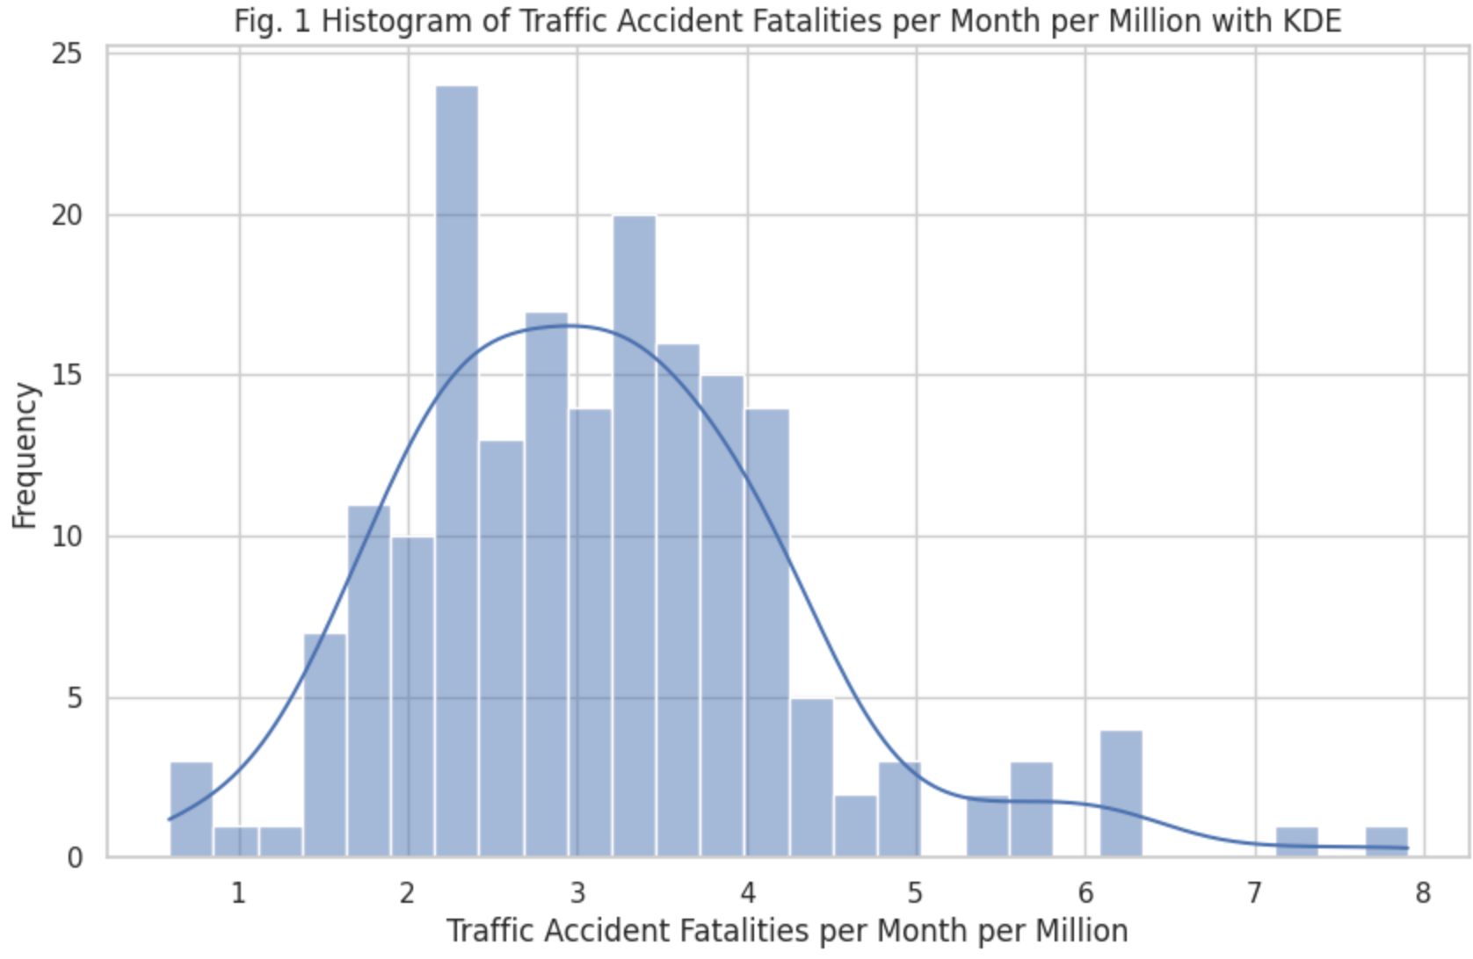

Figure 2 below depicts the trend in traffic fatalities per million people in Ireland, spanning from January 2008 to July 20223.

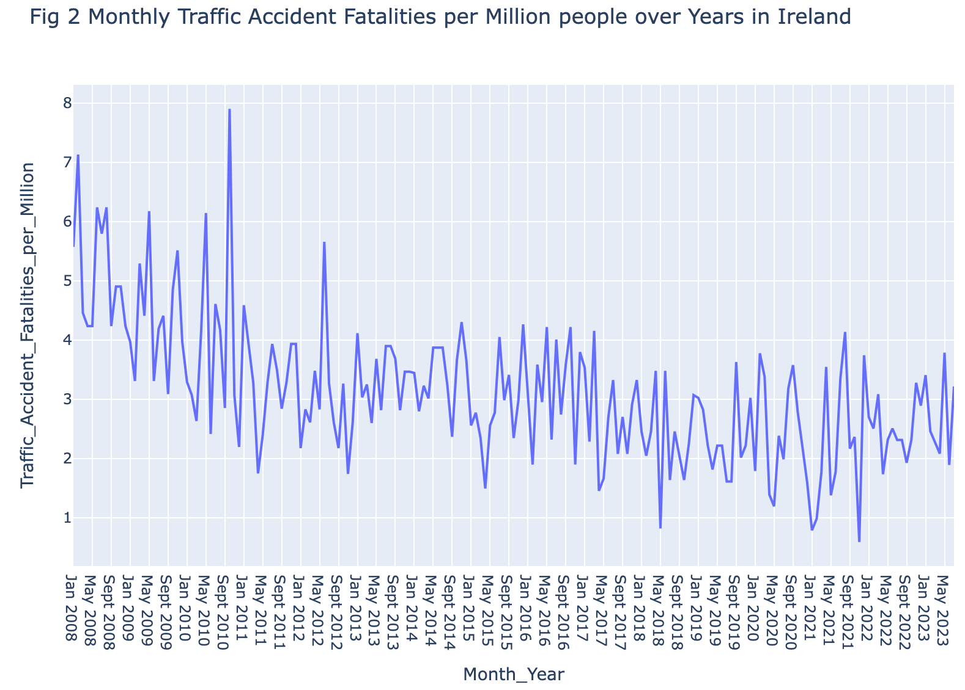

As could be observed in Figure 2, there is considerable month-to-month variation in traffic fatalities per million people. Therefore, the monthly average traffic fatalities for each year were calculated to analyze the data more effectively.

Figure 3 below illustrates the trend in these monthly averages from 2008 to 2023.

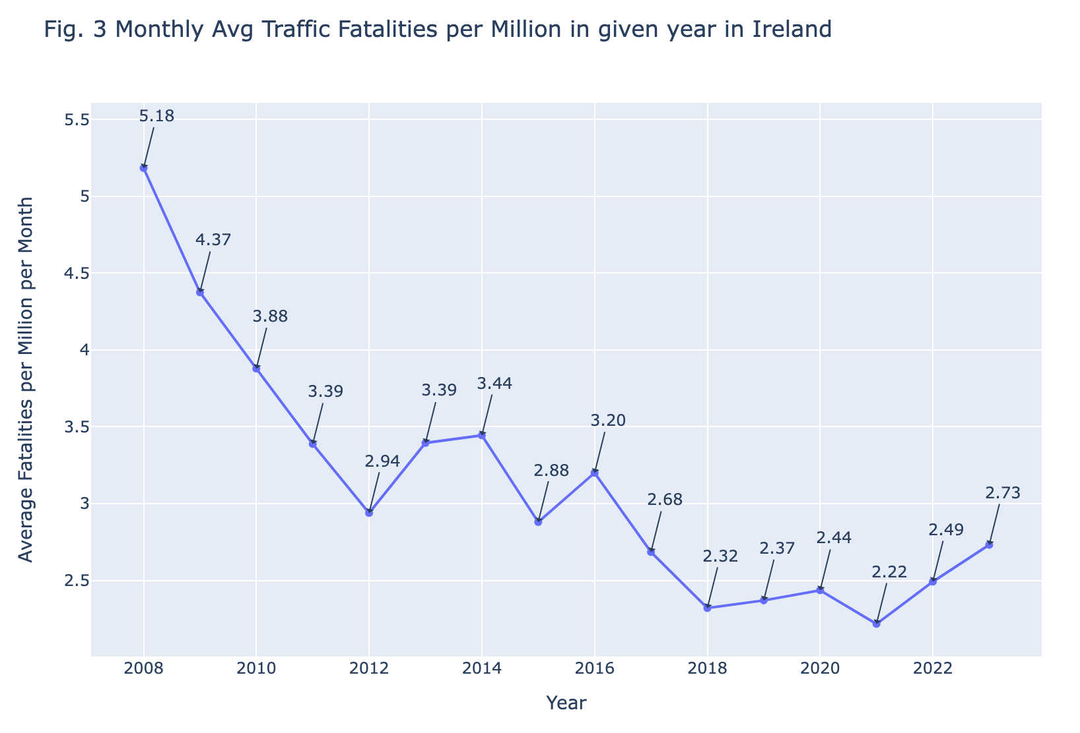

Table 2 below displays the year-on-year percentage change in monthly average traffic fatalities.

| **Year** | **Monthly Average Traffic Fatalities for given year** | **Year on Year % change in Monthly Average Traffic Fatalities (in %)** |
| --- | --- | --- |
| 2008 | 5.184 | NaN |
| 2009 | 4.375 | -15.604 |
| 2010 | 3.879 | -11.343 |
| 2011 | 3.388 | -12.650 |
| 2012 | 2.939 | -13.260 |
| 2013 | 3.395 | 15.521 |
| 2014 | 3.444 | 1.453 |
| 2015 | 2.880 | -16.388 |
| 2016 | 3.200 | 11.118 |
| 2017 | 2.685 | -16.097 |
| 2018 | 2.320 | -13.587 |
| 2019 | 2.370 | 2.138 |
| 2020 | 2.435 | 2.775 |
| 2021 | 2.217 | -8.974 |
| 2022 | 2.492 | 12.394 |
| 2023 | 2.732 | 9.641 |
| **Mean Year on Year Change in %** | | **-3.524** |

The calculated mean year-on-year percentage change in the monthly average of traffic fatalities, as outlined in Table 2, stands at -3.52%. This signifies a consistent downward trend in traffic fatalities per million in Ireland, reflecting an average annual decrease of 3.52% over the extended period from 2008 to 2023. In absolute terms, the Average Monthly fatalities per Million during this period has experienced a decline of approximately 47.2%. This statistical analysis suggests a notable and sustained improvement in road safety, as evidenced by the decreasing trend in the occurrence of traffic fatalities over the specified years.

**4.2 Analysis of Traffic fines issued:**

Similar to the normalization of traffic fatalities in Ireland per million of the population, the number of traffic fines issued for various infractions has also been normalized. The average number of fines issued per month for each type of infraction for a given year was calculated to facilitate this analysis.

Figure 4 below illustrates the trends in average monthly traffic fines issued per million over time.

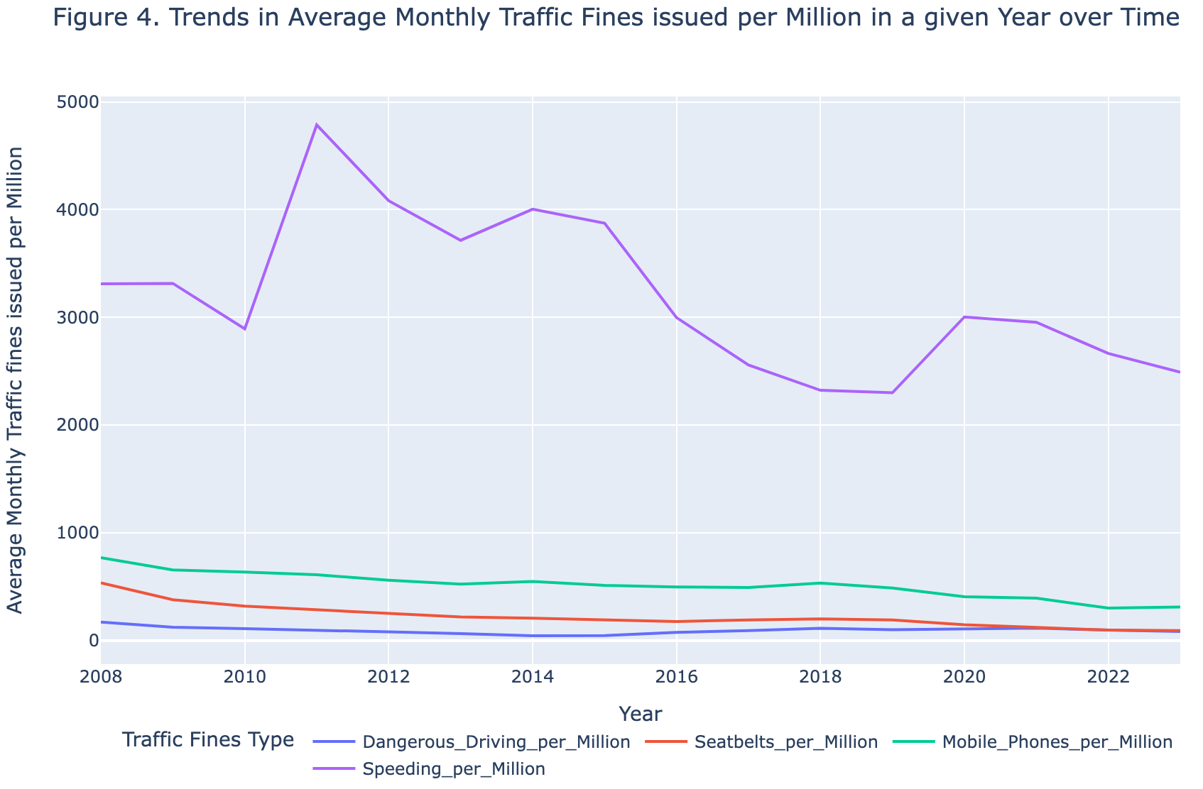

From Figure 4, the two key observations can be made:

1. The vast majority of fines issued are for speeding infractions, accounting for more than two-thirds of all traffic fines in a given year.
2. There is a noticeable declining trend in the number of fines issued from 2008 to 2023 across all categories of infractions.

Table 3 below presents the percentage share of each fine type of the total fines issued annually.

| **Year** | **Average Monthly Fines issued in a Given year per Million** | | | | | **Percentage share of Fine type in Total Fines issued** | | | |
| --- | --- | --- | --- | --- | --- | --- | --- | --- | --- |
| **Dangerous Driving** | **Seatbelts** | **Mobile Phones** | **Speeding** | **Total Fines** | **% Dangerous Driving** | **% Seatbelts** | **%**  **Mobile Phones** | **% Speeding** |
| 2008 | 168.97 | 533.71 | 768.15 | 3310.42 | 4781.26 | 3.53 | 11.16 | 16.07 | 69.24 |
| 2009 | 121.16 | 376.70 | 653.85 | 3315.12 | 4466.83 | 2.71 | 8.43 | 14.64 | 74.22 |
| 2010 | 107.94 | 318.03 | 633.67 | 2892.97 | 3952.63 | 2.73 | 8.05 | 16.03 | 73.19 |
| 2011 | 96.47 | 286.40 | 608.79 | 4786.97 | 5778.63 | 1.67 | 4.96 | 10.54 | 82.84 |
| 2012 | 78.71 | 250.96 | 558.43 | 4082.42 | 4970.52 | 1.58 | 5.05 | 11.23 | 82.13 |
| 2013 | 62.08 | 217.13 | 522.57 | 3714.92 | 4516.71 | 1.37 | 4.81 | 11.57 | 82.25 |
| 2014 | 42.77 | 206.53 | 547.57 | 4003.80 | 4800.66 | 0.89 | 4.30 | 11.41 | 83.40 |
| 2015 | 44.73 | 192.54 | 511.45 | 3873.32 | 4622.03 | 0.97 | 4.17 | 11.07 | 83.80 |
| 2016 | 73.38 | 174.21 | 496.31 | 2997.06 | 3740.96 | 1.96 | 4.66 | 13.27 | 80.11 |
| 2017 | 90.33 | 190.14 | 490.12 | 2557.53 | 3328.12 | 2.71 | 5.71 | 14.73 | 76.85 |
| 2018 | 112.56 | 198.52 | 531.81 | 2322.16 | 3165.04 | 3.56 | 6.27 | 16.80 | 73.37 |
| 2019 | 99.31 | 189.99 | 486.57 | 2299.03 | 3074.91 | 3.23 | 6.18 | 15.82 | 74.77 |
| 2020 | 107.52 | 145.45 | 405.54 | 3003.09 | 3661.60 | 2.94 | 3.97 | 11.08 | 82.02 |
| 2021 | 112.98 | 119.48 | 391.58 | 2953.90 | 3577.95 | 3.16 | 3.34 | 10.94 | 82.56 |
| 2022 | 96.26 | 95.18 | 299.03 | 2663.90 | 3154.37 | 3.05 | 3.02 | 9.48 | 84.45 |
| 2023 | 82.33 | 90.56 | 310.21 | 2489.78 | 2972.88 | 2.77 | 3.05 | 10.43 | 83.75 |

The data in the above Table 3 highlights the general decline in monthly average number of fines issued from 2008 to 2023. Of the fines issued, seat belt infractions have exhibited the most average annual decline, followed by mobile phone use, dangerous driving, and speeding infractions. Specifically, fines for seatbelt violations have decreased by an average of approximately 10% each year. In absolute terms, from 2008 to 2023, the monthly average number of fines issued for seatbelt violations per million declined by about 83%, mobile phone violations per million use by 59%, dangerous driving per million by 51%, and speeding violations by 24%.

Table 4 below details the year-on-year percentage change in average monthly traffic fines issued per category. The mean percentage change for each type of fine reveals the overall declining trend in fines issued over the studied period.

| **Year** | **Year on Year % change in Average Monthly Traffic fines issued in Given year** | | | |
| --- | --- | --- | --- | --- |
| **Dangerous Driving** | **Seatbelts** | **Mobile Phones** | **Speeding** |
| 2008 | NaN | NaN | NaN | NaN |
| 2009 | -28.30 | -29.42 | -14.88 | 0.14 |
| 2010 | -10.90 | -15.57 | -3.09 | -12.73 |
| 2011 | -10.63 | -9.95 | -3.93 | 65.47 |
| 2012 | -18.41 | -12.37 | -8.27 | -14.72 |
| 2013 | -21.13 | -13.48 | -6.42 | -9.00 |
| 2014 | -31.12 | -4.88 | 4.78 | 7.78 |
| 2015 | 4.58 | -6.77 | -6.60 | -3.26 |
| 2016 | 64.06 | -9.52 | -2.96 | -22.62 |
| 2017 | 23.11 | 9.15 | -1.25 | -14.67 |
| 2018 | 24.60 | 4.41 | 8.51 | -9.20 |
| 2019 | -11.77 | -4.29 | -8.51 | -1.00 |
| 2020 | 8.27 | -23.45 | -16.65 | 30.62 |
| 2021 | 5.07 | -17.85 | -3.44 | -1.64 |
| 2022 | -14.80 | -20.34 | -23.64 | -9.82 |
| 2023 | -14.46 | -4.86 | 3.74 | -6.54 |
| **Mean % Change** | **-2.12** | **-10.61** | **-5.51** | **-0.08** |

1. **Inferential Statistical Analysis:**

**5.1 Regression Analysis of Traffic Fatalities and Traffic Fines Imposed:**

Traffic fatality rates serve as a crucial metric globally, monitored by governments to assess road safety. In an effort to enhance roadway conditions, authorities implement a variety of safety regulations, conduct road safety awareness campaigns, and levy fines for violations as a means to enforce compliance with traffic laws. These measures collectively contribute to promoting safer and more secure conditions on the roads.

A pragmatic method to evaluate the impact of these regulations and campaigns is to examine the correlation between the intended safety outcomes and the enforcement metrics, such as the frequency of traffic fines issued. In this context, the number of fines levied for specific infractions can serve as an indirect measure of rule adherence within the population. For instance, an increase in fines for mobile phone usage while driving could indicate a higher proportion of drivers disregarding this particular road safety regulation.

In our regression analysis, we adopted a simple linear regression approach, examining the relationship between traffic fatalities and each type of traffic fine independently. This method enables a clear investigation into how each specific infraction type—dangerous driving, seatbelt non-compliance, mobile phone use, and speeding—individually correlates with the rate of traffic fatalities. By isolating the variables, we gain a straightforward understanding of each factor's impact.

***Which Traffic Safety Rule Enforcement has Profound Impact on Traffic Fatalities?***

Figure 5 below displays a series of scatter plots correlating the average monthly traffic accident fatalities per million with the average monthly fines issued for four types of traffic violations: dangerous driving, seatbelt violations, mobile phone usage while driving, and speeding.

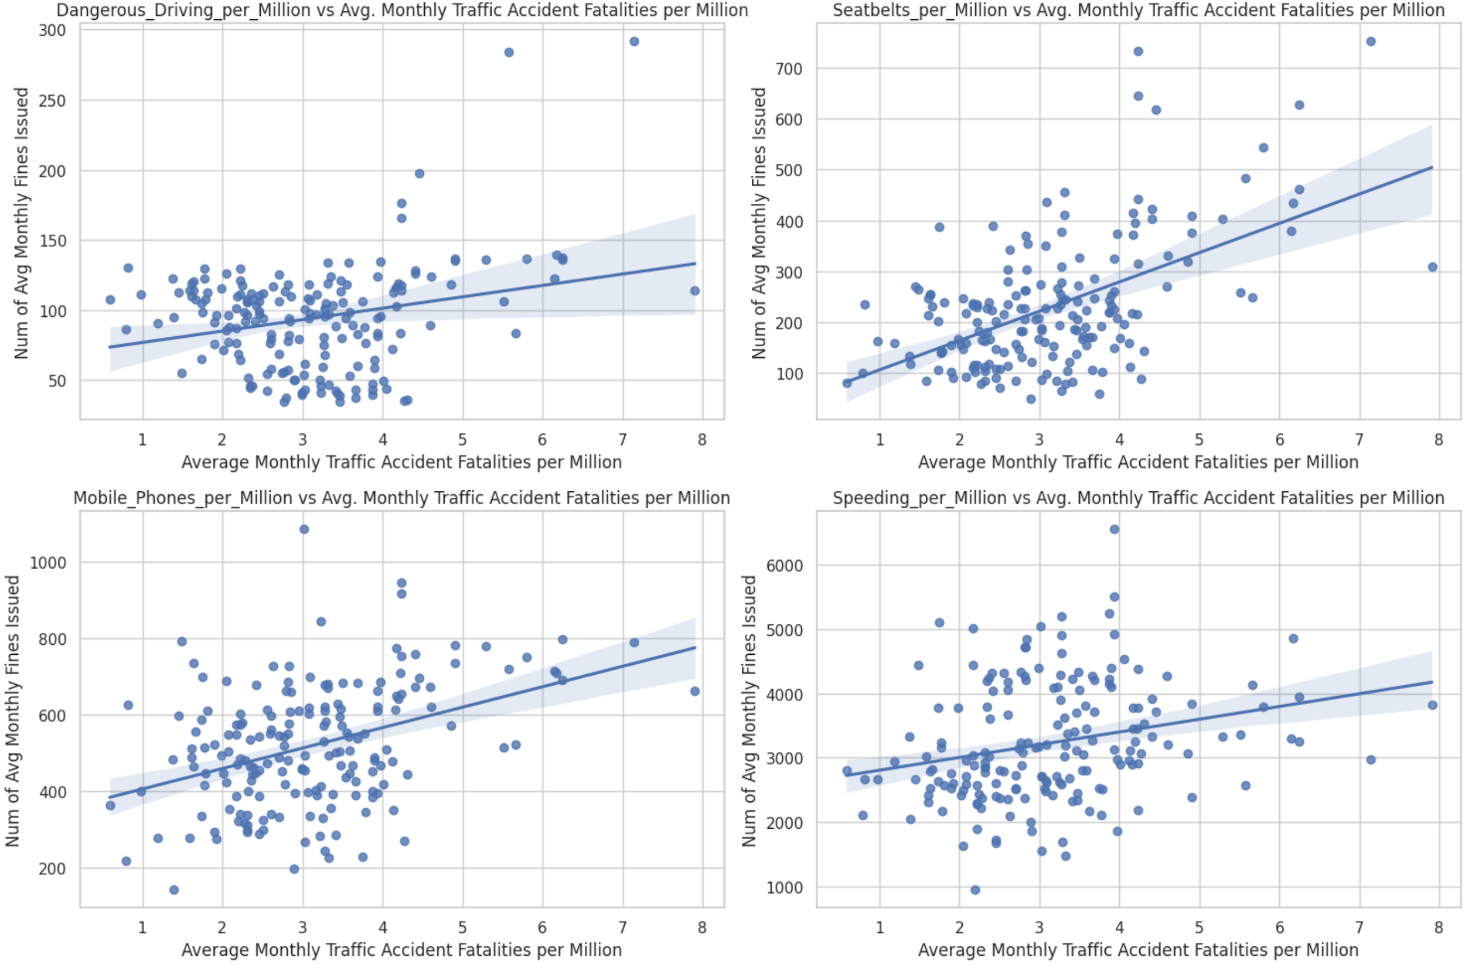

Table 5 below presents the results of independent regression analyses using OLS (Ordinary Least Square) method for each type of traffic fine. The R-squared values serve as indicators of the proportion of variance in the monthly average traffic fatalities per million that can be explained by each independent variable. The p-values offer a measure of the evidence against the null hypothesis which is that there is no relationship between the independent and dependent variables.

| **Independent Variable( Types of fines issued)** | **B0** | **B1** | **R Squared** | **p-value** |
| --- | --- | --- | --- | --- |
| Dangerous Driving | 2.34 | .0083 | 0.067 | 0.000375 |
| Seatbelts | 1.956 | .0051 | 0.296 | 1.51E-15 |
| Mobile Phones | 1.586 | .003 | 0.158 | 2.21E-08 |
| Speeding | 2.056 | .0003 | 0.066 | 0.000442 |

From our regression analysis, we could infer that all types of traffic fines have a positive correlation with reduction in Traffic fatalities. The seatbelt violations exhibit the highest R-squared value among the examined traffic fines. This suggests a substantial association between the variations in the number of seat belt-related fines issued and variations in traffic fatalities. The low p-value for seatbelts among all the types of traffic fines provides evidence of the statistical significance of seatbelt violations in the model, reinforcing the role of seatbelt use in reducing traffic accident fatalities.

Under the assumption of consistent Garda Síochána enforcement of traffic rules over the study time period, the observed decline in traffic accident fatalities and a sharp decline in the number of seat belt fines issued indicates a growing public adherence to seatbelt regulations which in turn is potentially contributing to the reduction in traffic accident fatalities.

**5.2. Are the roads in Ireland safer now than they were 10 years back?:**

We evaluate this question by taking 2 approach:

1. Unpooled t-test
2. ANOVA (Analysis of Variation)

**Unpooled t-test:**

We have divided our dataset into two distinct time spans:

i) January 2008 to December 2017, representing the initial 10 years.

ii) January 2018 to July 2023, encompassing the subsequent time frame.

The null hypothesis (H0) formulated for this study posits that there is no discernible alteration in the mean monthly traffic accident fatalities between the recent period of 2018-2023 and the preceding 10 years.

Therefore, **H0: μ1 - μ2 = 0**

Table 6 below shows the mean and standard deviation of Monthly Average road traffic fatalities in a given year for respective time periods.

| **Time Period** | **Monthly Average Road Traffic Fatalities in give year** | |
| --- | --- | --- |
| **Mean** | **Standard Deviation** |
| Jan 2008 to Dec 2017 | 3.54 | 1.15 |
| Jan 2018 to July 2023 | 2.4 | 0.8 |

Figure 6 below displays the KDE of Monthly Average road traffic fatalities for the two time periods.

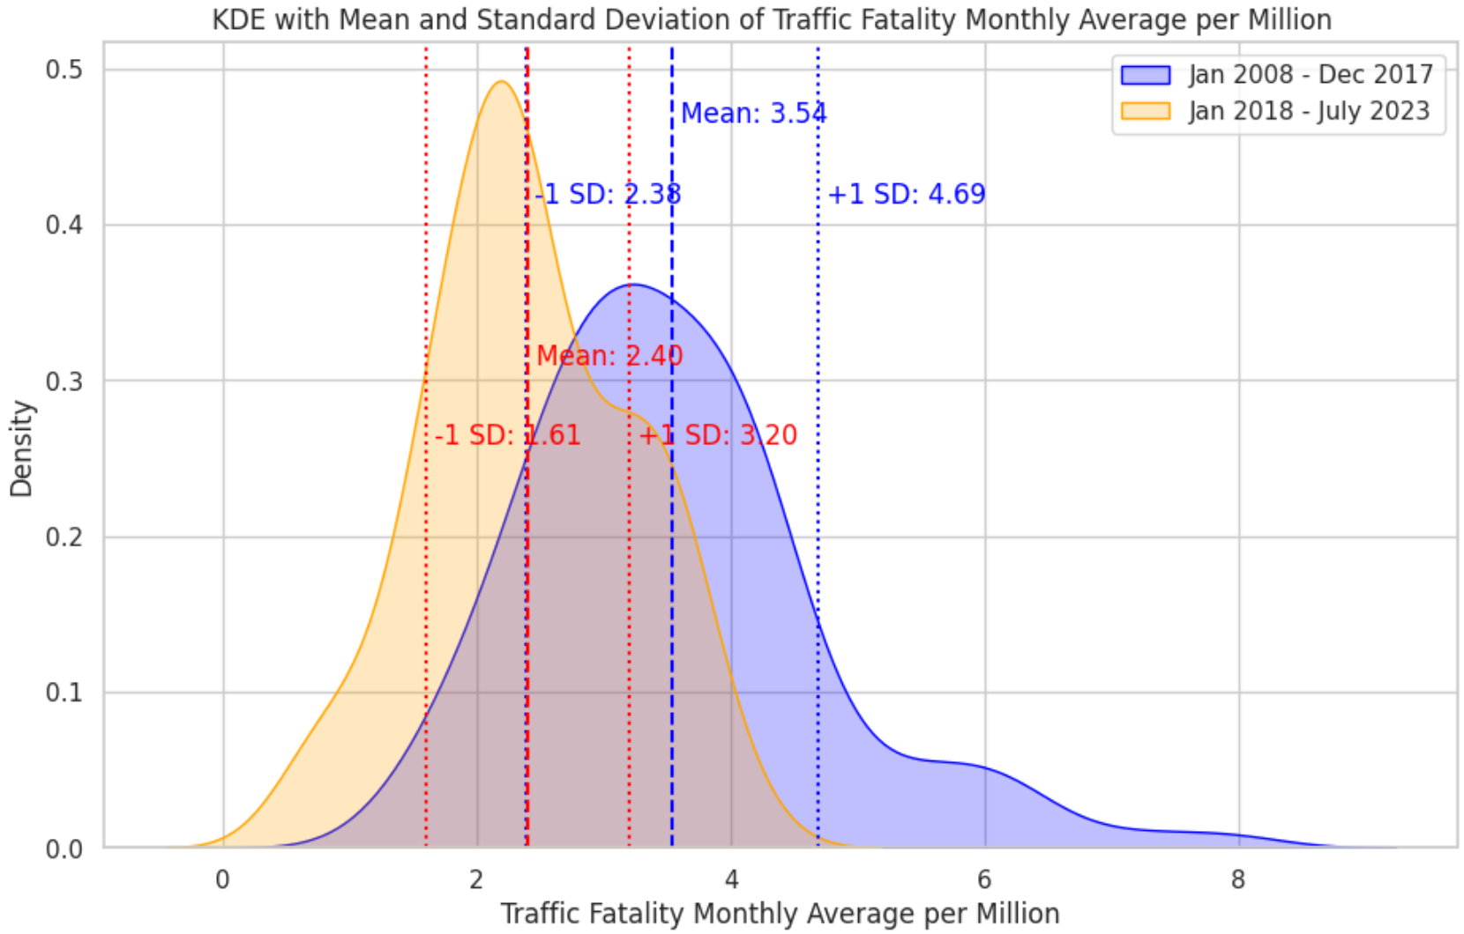

The un-pooled t-statistics test result are:

T-statistic: 7.839459929764484,

P-value: 4.155675970394681e-13.

Since the p value is less than .05 we can reject our null Hypothesis and since the mean monthly traffic fatalities in later time period is less than the earlier time period, we can infer that roads now in Ireland are safer than 10 years back.

**ANOVA (Analysis of Variation):**

We've divided our dataset into three distinct time intervals:

1. January 2008 to December 2012
2. January 2013 to December 2017
3. January 2018 to July 2023

The null hypothesis (H0) for our ANOVA analysis posits that there is no discernible variation in the mean monthly traffic accident fatalities across these three selected time frames

Therefore, **H0: μ1 = μ2 = μ3**

Table 7 below displays the Mean and Standard Deviation of Monthly Average road traffic fatalities in a given year for respective time periods.

| **Time Period** | **Monthly Average Road Traffic Fatalities in give year** | |
| --- | --- | --- |
| **Mean** | **Standard Deviation** |
| Jan 2008 - Dec 2012 | 3.95 | 1.33 |
| Jan 2013 - Dec 2017 | 3.12 | 0.74 |
| Jan 2018 - July 2023 | 2.4 | 0.8 |

Figure 7 below displays the KDE of Monthly Average road traffic fatalities for the three time periods selected for ANOVA Analysis:

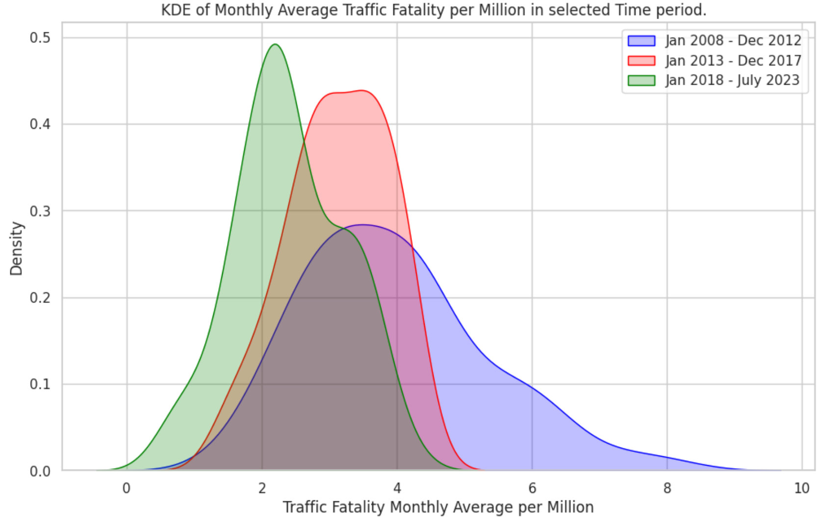

**ANOVA Analysis Results:**

| ***Source of Variation*** | ***SS*** | ***df*** | ***MS*** | ***F*** | ***P-value*** | ***F crit*** |
| --- | --- | --- | --- | --- | --- | --- |
| Between Groups | 75.790 | 2 | 37.895 | 38.450 | 1.09e-14 | 3.045 |
| Within Groups | 181.342 | 184 | 0.986 |  |  |  |
| Total | 257.133 | 186 |  |  |  |  |

The p-value of ANOVA analysis is less than .05. Hence we reject the Null Hypothesis. Since the mean Traffic fatalities in the latest time period is less than that of mean from the preceding two time period we can infer that roads now in Ireland are safer than 10 years back.

1. **Conclusion:**

The findings presented in this report strongly suggest that road safety in Ireland has markedly improved over the past decade. Both the un-pooled t-test and ANOVA analyses reveal a statistically significant decrease in the monthly average of road traffic fatalities. This provides compelling evidence that the implemented measures aimed at enhancing road safety have proven effective. The noteworthy decline in fatalities, as indicated by the reduced mean in more recent time frames, underscores the success of strategies implemented by the Road Safety Authority and the consistent enforcement efforts by An Garda Síochána. Furthermore, the public's adherence to traffic safety regulations, such as the use of seatbelts, plays a pivotal role in minimizing traffic accident fatalities.